Mark Stearns
2/4/14

CodeIgniter

Summary: CodeIgniter is an open source development web application framework, for the use in building dynamic web sites with PHP. It is based on the MVC (Model-View-Controller) architecture - you don't have to use a command line. Its goal is to enable users to develop projects much faster than writing code from scratch, by providing a rich set of libraries for commonly needed tasks. CodeIgniter was developed by EllisLab, Inc. CodeIgniter has a simple interface and logical structure to access these libraries. It was first released in February of 2006 and the latest version (2.1.4) was released in July of 2013.

Requirements: it is just about 2 MB, it works with all servers and web hosting accounts that provide PHP version 4.3.2 or newer, requires a database for most web applications. Current supported ones are MySQL (4.1+), MySQLi, MS SQL, Oracle, SQLite. Supports Windows and OS X. CodeIgniter 2.1.3 needs PHP 5.1.6, but versions before 2 still works with PHP 4.

Pro’s | Con’s
- Speed when compared to other PHP frameworks  - PHP creator Rasmus Lerdorf said he liked CI because it is faster, lighter and the least like a framework  - CI is open source and is maintained at GitHub  - Easy to use  - Documentation is widely considered to be good  - Large support community  - At a time was most popular PHP framework  - Screencasts, written tutorials, and third party libraries | - Structured around the capabilities of PHP4  - Lack of leadership  - Has not been able to implement any features available in PHP 5.3  - Code modularity is one of the worst in the industry  - Have to rely on Sparks system for libraries  - EllisLabs has been focusing their attention to another product so changes to framework has been insignificant

Related Technologies: Laravel, Phalcon, Symfony2, Rails, FuelPHP

Opinion: From my understanding it seems that CodeIgniter is one of the easiest to use frameworks. It takes the crown for beginners using PHP. Since I am a beginner I would give it a shot, it has a lot of documentation and tutorials throughout the web.

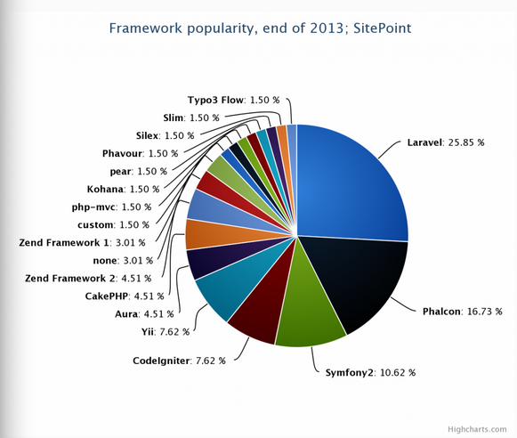

Highcharts

Summary: is a freely available open source library that provides an elegant and feature complete approach for including chart visualizations using pure Java code. It offers intuitive interactive line, spline, area, area spine, column, bar, spire and scatter chart types. It is solely based on native browser technologies and doesn’t require client side plugins like Flash or Java, allowing charts to run on modern mobile devices. The data must be inputted in JSON format.

Requirements: Works on all desktops, iOS, and android devices. Per-developing licensing fee starts at $390 per developer. Website licenses at $90. Non-commercial usage is free.

Pro’s | Con’s
- Very robust set of chart types  - Customizable  - Animation features  - Can pull in data from wide range of sources  - Zooming feature to see closer  - Themable = more consistent  - Filtering = allow user to show and hide series of data  - Highstock = date ranges, date picker, scrolling and panning  - Users can mouse over items for more details  - Users can click on chart legend to turn them on and off  - Little customization needed to get a sleek-looking chart | - Cost  - Documentation is mediocre  - Distinctive look  - Charts are not interactive on android phone  - Rendering can be slow in older browsers like IE 6/7  - Skill level = intermediate/expert  - Learning curve

Related Technologies: Google Chart Tools, jQuery Visualize, JavaScript InoVis Toolkit, D3.js, Simile Exhibit

Opinion: Highcharts seems like the most flexible data visualization frameworks out there. Although it comes at a cost my understanding is you get what you pay for. Additionally the software is free for non-commercial use. My interests are within the financial markets and this software will give me the ability to chart and graph a number of data series throughout an API in an elegant fashion. In conclusion, I would really like to give Highcharts and especially highstocks a shot.

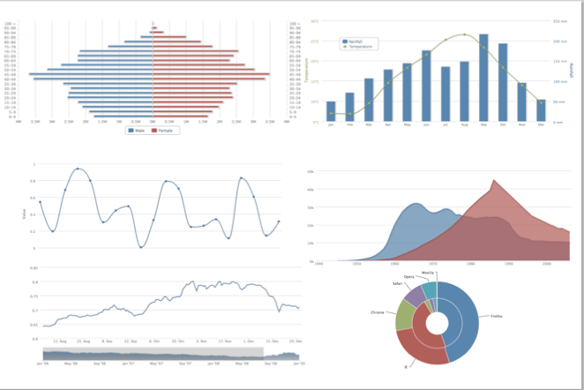

http://www.moxiegroup.com/moxieapps/gwt-highcharts/showcase/#featured-area

